**Classroom Activity​-Write a program to print HELLO WORLD 5 times using While Loop​**

**​**

**Code-**

​

**Output-**

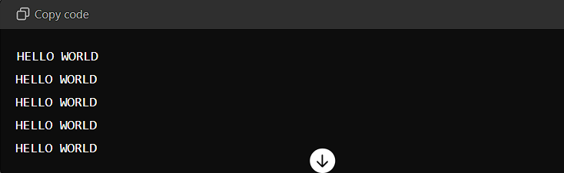

**Execution-Steps:**

Create a JavaScript file with any name

Write the code

And run the code in the terminal using F5 or right click and go to inspect and you can get the output in the console as well..